**CHILD CARE CONNECTIONS**

Serving COLUMBIA, GREENE & ULSTER COUNTIES

**39 John St.**

**PO Box 3516**

**Kingston, NY 12402**

(845) 331-7080 Fax (845) 331-0526

**351 Fairview Avenue, Suite 310**

**Hudson, NY 12534**

(518) 822-1944 Fax (518) 822-8233

**Staff:** 12 full-time, 2 part-time (and 2 FT positions vacant)

**Team Leader:** Kerry Wolfeil (Ulster, Columbia and Greene)

**Program Director:** Suzanne Holdridge (Columbia/Greene)

Penny Dombrowski(Ulster)

**Program Hours:** Monday - Thursday 8:00am - 5:00pm, Friday 8:00am – 4:00pm (Ulster)

Monday – Friday 8:00am – 4:00pm (Columbia/Greene)

PRIMARY FUNCTIONS

Child Care Connections is a child care resource and referral program of Family of Woodstock, Inc., serving Columbia, Greene and Ulster Counties. Staff provide families with referrals to legal child care programs as well as information on financial support. They recruit and regulate legal child care programs to ensure the health, safety and quality of care for children. The program sponsors child care programs to participate in the Child and Adult Care Food Program (CACFP) and Summer Foods Service Program (SFSP), which provides a significant amount of reimbursement for serving nutritious meals. Finally, staff advocate for child care professionals, and educate families and communities on the importance of early childhood development.

ANCILLARY SERVICES

Community coordination concerning child care issues; technical assistance to employers on child care issues, including employer supported child care options.

DEMOGRAPHY OF CLIENTS

Families of all income levels with children 6 weeks - 13 years of age; child care professionals and programs; employers; and government officials in the three county region.

2021 ACCOMPLISHMENTS

Child Care Referral Services**:** Parent Referral and Consumer Education managers provided child care referrals to **449 unduplicated families**. Families were given referrals to legal child care providers who most closely met the family’s needs and were sent a child care informational packet based on their specific requirements. Parents were also given specific information and resources concerning behavioral and health and safety issues, age appropriate activities, and social and emotional development.

|  |  |  |  |  |
| --- | --- | --- | --- | --- |
| **2021** | **Number of Families Served** | **% Families that contact for additional services** | **Number of Unduplicated Children Served** | **Number of Referrals Given(families may have contacted more than once for additional services)** |
| **Columbia** | **92** | **14%** | **132** | **107** |
| **Greene** | **80** | **16%** | **117** | **95** |
| **Ulster** | **277** | **19%** | **1080** | **345** |
| **Total** | **449** |  | **1329** | **547** |

**Child Care Programs:**

In the 3 counties there are various modalities of regulated child care to meet the needs of families. All providers must be registered or licensed by the NYS Office of Children and Families Services (OCFS) and all staff of regulated programs must participate in at least 30 hours of training every 2 years. The following are the various child care program modalities:

• Day Care Center - cares for more than 6 children in a non-residential facility with classrooms for different age groups and child to adult ratios that are based on the age of the children in the group.

• School Age Child Care - cares for children 5 to 12 years of age in a non-residential facility.

• Group Family Day Care - cares for a maximum of 12 children, plus an additional 4 school age children in the provider’s own home. Only 4 children under the age of 2 years old may be served at a time in an approved site. A Group Family Day Care home must be licensed by the NYS Office of Children and Family Services.

• Family Day Care - cares for 3-6 children, plus an additional 2 school-age children, in the provider’s own home. Only 2 children under the age of 2 years old may be served at a time in an approved site. Registration with NYS/OCFS is required to care for more than 2 non-related children.

• Legally Exempt Enrolled programs - care for a maximum of 2 children, not including their own, in the provider’s home. If child care is provided in the child’s home, the provider can care for all of the children of that family. There are no formal training requirements, but participation in training is encouraged.

The chart below shows the amount of regulated child care available as of 1/11/2022 by county.

|  |  |  |  |  |  |  |
| --- | --- | --- | --- | --- | --- | --- |
| **Type of Care** | **Columbia** | | **Greene** | | **Ulster** | |
|  | Programs | Slots | Programs | Slots | Programs | Slots |
| Day Care Centers | 11 | 440 | 8 | 344 | 47 | 2419 |
| School Age Programs | 4 | 258 | 5 | 280 | 23 | 1362 |
| Group Family Day Care | 10 | 154 | 4 | 60 | 30 | 1362 |
| Family Day Care | 7 | 56 | 9 | 72 | 40 | 319 |
| Legally Exempt Care* | 16 | 32* | 6 | 12* | 55 | 110* |

*Note: the numbers are approximate because the legally exempt providers can serve up to two non-related children, and more if in-home care is being conducted in the child’s home.

There has been a crisis in child care which has been worsening over the last 10 years. With the Covid-19 pandemic, children not being physically in school, unemployment rates high, parents finding other alternative care, child care programs closing due to OCFS/DOH Covid requirements, the decline in child care has significantly increased. However, the decline preceded the pandemic. Some of the current factors are: the increasing cost of child care; the need for non-traditional business hours; the increase in comprehensive background checks for legally Exempt Providers; the constant change in pandemic guidance; and increased regulations. One result is that there has been an increase in the provision of illegal, unregulated child care. It should be noted that while most parents would like their children, particularly their youngest children, to be in a home-like environment, the care that has taken the biggest hit is in legally exempt and family day care. This, at least in part, has to do with the financial viability of those program models and the stress of working alone with young children with no ability for self care and time off.



**Day Care Registration:**

Unfortunately, child care application submission continues to decline. In the entirety of Columbia, Greene and Ulster Counties, there were only **52 (15 Family Day Care, 3 School Age Child Care) applications requested** and **13 (6 Family Day Care) applications received** in 2021. Only **93 (1 Family Day Care, 84 Legally Exempt, 1 School Age Child Care) programs opened**, while **93 programs (10 Family Day Care, 67 Legally Exempt, 5 School Age Child Care)** closed in 2021, with the majority of programs being Legally Exempt. The landscape of child care continues to change due to the increasing cost of child care, need for non-traditional business hours, constant change in pandemic guidance, and increased regulations. The unemployment, school closings, remote learning, quarantine requirements, and families using illegal child care or family and friends to patchwork child care together has also caused a decline in retention and application submission. Child Care continues to be a crisis in the community, as well as NYS as a whole. Quarterly monitoring inspections were suspended throughout 2021 with **78 Family Day Care, 65 School Age Child Care and 6 Legally Exempt inspections** conducted.

**Child Care Program Training and Technical Assistance:**

Child Care Connections supports all forms of child care to improve the quality of care provided to children in the 3 counties. The program offers providers the following supports: phone, e-mail, and in person basic technical support; group training workshops; one on one consultations; on-site training; and intensive technical assistance. In 2021 the basic technical assistance shifted as many programs closed, stopped caring for children or were too burnt out to take in any new children or program improvements. Intensive Technical Assistance continues to be lower than usual due to COVID pandemic since staff are still not entering programs as usual. Programs do not want outside people in the programs if not required. There was very little training offered due to the pandemic and restrictions of groups. We did hold virtual trainings and minimal in person trainings. Staff continued to work with programs to share free and low cost creditable training for their program. Child Care Connections currently has staff that has completed their NAEYC trainer’s credential being able to offer virtual training for child care programs.

In 2021 the program provided the following technical assistance:

|  |  |  |  |
| --- | --- | --- | --- |
|  | **Basic Technical Support Contacts** | **Provider Training Hours/Attended** | **Intensive Technical Assistance Hours/Programs** |
| **Columbia** | 299 | 6/48 | 27.75/15 |
| **Greene** | 246 | 18/6 | 37/22 |
| **Ulster** | 372 | 34/70 | 48.75/29 |
| **TOTAL** | **917** | **58/124** | **113.5/66** |

A contract through ECLC was offering 10.5 hours of in person training. The Blending and Braiding Funds to Support Early Childhood Programs was offered for free through the New York State Birth to Five grant (PDG B-5). This training looked at the "Blending and Braiding Funds to Support Early Childhood Education Programs" guide to allow child care providers to define the terms blending and braiding, describe the stages required to develop a Blended and Braided fiscal model, and participate in activities designed to help them through the process of setting up a blended and braided model.

A contract through ECLC was offering 18 hours of in person training. The Core Business Training Series was a six-session comprehensive training on business topics intended for child care providers. The sessions included content on business and financial structure; ongoing financial management; staff recruitment, management, and retention; marketing; program contracts and policies; and facilities and liability.

**Child and Adult Care Food Program (CACFP):**

**Homes:** Child Care Connections distributed **$286,312** in reimbursement to child care providers participating in the food program to keep child care costs low, while ensuring nutritious meals were served. On average, 38 child care providers serve nutritious meals and complete menus that meet the USDA Guidelines to receive food support funding each month. 62 monitoring visits took place to observe meal service, review required documentation and offer nutritional and health information. Starting in December 2020 monitor visits were being conducted over the telephone or virtually. October 2021 in person monitoring visits started again, to only be suspended again in December 2021 until September 2022 or the end of the pandemic. Staff will continue to conduct at least 2 monitor visits over the telephone or virtually.

**Centers:** Child Care Connections’ Child and Adult Care Food Program (CACFP) staff continue to assist our agency’s homeless shelters for youth and families and 4 Community Centers to improve their menus, offer staff training, give technical assistance, and provide oversight of CACFP. The program offers nutritious meals and snacks daily, incorporates a family style meal service, increases basic living skills and teaches how to make healthy lifestyle changes eating the foods allowed by CACFP. In 2021: Family House, the agency’s runaway and homeless youth shelter, provided **3,086** reimbursable meals/snacks to adolescents residing at the shelter; the Hodge Center prepared **9994 reimbursable** meals for youth at the City of Kingston Everett Hodge Community Center (2839), City of Kingston Rondout Neighborhood Center (1373), Kingston Boys and Girls Club (1138), and Center of Creative Education (1558) in 2021.

**Summer Food Service Program**: In order to mitigate the loss of school breakfast and lunch programs during the summer and while schools are closed for remote learning or hybrid model during January-August 2021, the Hodge Center prepared 15,895 meals/snacks to **7** community sites, serving **8,137 breakfasts, 10 snacks, and 7748 lunches,** with a **reimbursement of $55,392 in 2021**

**Intensive Infant/Toddler Support:**

The program has received two grants which are paying for an Infant Toddler Specialist and Infant Toddler Mental Health Consultant to provide consultant support for providers serving young children. Both work 20 hours in Ulster County and 20 hours in Columbia and Greene Counties. While the visitations have been limited as a result of Covid-19, the initial work completed is listed below. Unfortunately, the staff were not allowed to provide facilitation online because they had not received their NAEYC trainer’s credential. The Infant Toddler Specialist is currently in the process to obtain that credential.

The Infant & Toddler Specialist provides support to our community by working directly with Child Care Providers and Families to promote safe, nurturing environments for our youngest population. The goal of the Specialist is to emphasize high-quality early care, which is essential to a child's long-term social, emotional, and intellectual development.

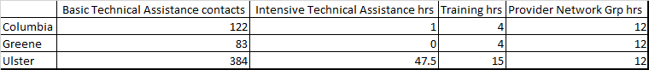

The Infant & Toddler Mental Health Consultant focuses on providing specific services to infant and toddler Parents and Child Care Providers. This is not therapy or a direct service to the child, but rather an intervention with Parents and Child Care Providers to improve the environment to better support the child. The Infant Toddler Mental Health Consultant has worked in **8 classrooms** (Ulster County 5 classrooms, *Delaware County 3 classrooms)throughout 2021.

**COVID Pandemic Funds:**

OCFS offered a CARES 2 grant to all modalities of child care for allowable expenses through a Reopening/Restructuring and/or Temporary Operating Assistance grant that Child Care Connections administered. **$379,622.20** was distributed to **57 child care programs** throughout Columbia, Greene, and Ulster Counties.

OCFS offered the (CARES 3) Essential Worker Scholarship grant opportunity to support the essential workers, who've served throughout the pandemic, to cover the cost of child care up to the market rate for over a 12-week period. Child Care Connections received the applications, approved or denied them, and paid **$469,289.90** to **33 child care programs** to pay for the childcare costs of **98 children** of essential workers.

**Early Learning and Literacy Network (ELLN) Grant:**

Throughout 2021, program staff were actively involved in the ELLN Committee, a group working in Columbia County, as part of the Leadership group. We co-chaired the Trusted Messenger subcommittee, which was responsible for working on county-wide mapping of where Trusted Messengers were serving Columbia County, with the number of messengers and families served. The focus was on increasing the ELLN and Talking is Teaching resources to support increased knowledge and engagement of literacy activities, and to model how to use the resources. **57 literacy bags** were delivered to families with infants and toddlers, bags included age appropriate books and developmental toys designed to increase literacy activities, along with written resources for parents, bibs, rattles, etc., sporting the Talk Read Sing logo and branding.

Additional long term goals were to track and monitor trends in Kindergarten screening results in each of the 6 county wide school districts. This has been difficult to obtain accurate outcomes due to disparities with traditional screening techniques not being utilized due to the pandemic, and not having access to longitudinal reports from the districts per age group. The pandemic has disrupted the traditional ways of tracking children, so this will continue to be a goal of the committee.

**Stabilization and Technical Assistance Provider Grants:**

The Stabilization grant was designed to provide impactful financial assistance to eligible New York State child care programs in a fast and easy way. OCFS created a simple online application that was available in 12 languages. Once approved, six monthly payments would be disbursed directly to the child care program. In an effort to provide language services to all our providers **2 radio interviews** via Zoom on La Voz with Mariel Fiori of Radio Kingston were conducted. **12 Online informational sessions** were hosted in both English and Spanish September through November 2021. **22 hours of technical assistance** was given to assist in creating their MY. NY.GOV ID account to be assisted through the application process or to be provided information about the grant. **438 Basic Technical Assistance** contacts were madein the three counties. **168 programs** applied and were approved to receive the Stabilization grant funds. A total amount of **$7,000,000 was approved** with **$4,900,000 in payments** made to date.

**Baby Bundle Bags:**

Family of Woodstock’s Child Care Connections is distributing FREE Baby Bundle kits, with the support from Preschool Development Grant Birth through Five Initiative (PDGB5), from the U.S. Department of Health & Human Services, Administration for Children and Families, and Office of Child Care. The kits are for families with newborns, and are designed to help the whole family build a strong foundation. **51 (44 Ulster, 3 Columbia, 4 Greene) Baby Bundle Bags** were distributed so far to families in Ulster Columbia, and Greene Counties.

**Creating Healthy Schools and Communities:**

The grant was received in July 2021. An executed contract with the grantor, City of Kingston, is still pending. This grant will span five years, will help to increase opportunities for physical activity and improve nutrition in early childhood education programs/child care programs located in the City of Kingston, Town of Ulster, Plattekill and Wawarsing. The position has not been filled and the work will not begin until March 2022. We will be working with eligible child care programs by reviewing the programs physical activity and nutrition policies and will provide suggestions and trainings to enhance these efforts. The goal is to create more opportunities for children to get the appropriate physical activity and nutrition needed to thrive.

**RECENT DEVELOPMENTS**

* The Child Care Connections renewed the NYS Standard of Excellence certification from the Early Care and Learning Council. This certification will be renewed again in December 2022.
* One of the current legislative bills before the NYS government will promote universal child care. The bill establishes the universal child care act to provide for the establishment and funding of universal child care in the state of New York. This bill attempts to improve the effectiveness of the available child care taskforce and increased appropriation. The bill is currently under consideration in the NYS Senate
* Senator Brisport is sponsoring the Universal Child Care Bill after he conducted a “Listening Tour” throughout NYS. On December 1, 2021Senator Brisport accompanied CCR&R Staff, Senator Hinchey, Assembly members Hevasi and Tague through Ulster, Greene and Columbia Counties visiting 3 child care sites. Later in the day a Roundtable session occurred with CCR&R, DSS, CSEA/Voice, Child Care business owners and parents. The day wrapped up with a virtual Town Hall meeting with more than 80 attendees from Columbia, Greene and Ulster County.

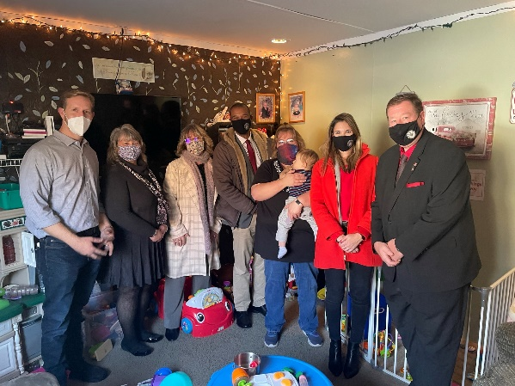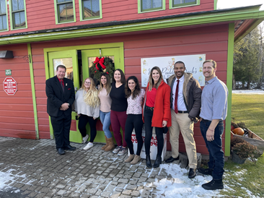

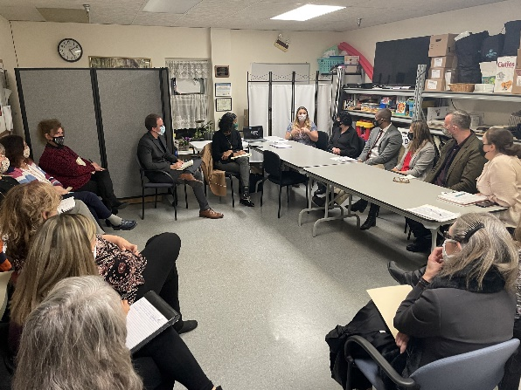

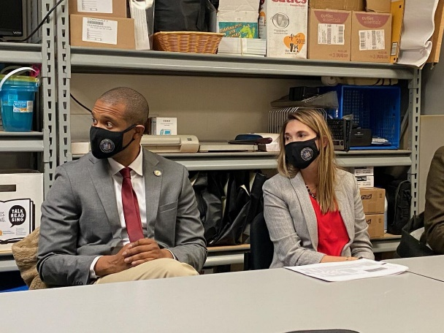

* Congress is considering legislation built around President Biden’s Build Back Better (BBB) plan. BBB includes policies and investments that, if enacted, would save families thousands of dollars in child care and preschool costs, and build a strong, stable early learning system that meets the needs of families, providers, and the economy.

The proposed federal investments in child care and pre-K, underscore the commitment of Congress and the Biden administration to finding solutions to America’s longstanding child care crisis by addressing widespread challenges to access, affordability, and quality in early learning, while reinforcing the benefits of a strong mixed-delivery system that prioritizes parent choice in determining the type and setting of care that best meets a family’s needs. The proposal seeks to resolve chronic foundational flaws in America’s child care market caused by decades of underinvestment, which have created an entirely unsustainable business model for providers that often translates into near-poverty wages for early educators.

Additionally, the proposal would build on existing state and federal preschool programs by providing funding to cover the federal share of the cost of a voluntary, free universal pre-K (UPK) program for all children, regardless of income or other eligibility requirements, in a variety of settings. (source: <https://www.ffyf.org/author/aguarino/>)

* Information Sessions have again been scheduled to run in 2022 for individuals interested in starting a child care business or expanding their operating child care business in a Child Care Desert. There will be funding available for these sites.
* Billboards are being displayed throughout Columbia, Greene and Ulster Counties promoting Legally Exempt Care and Child Care Subsidy information. There has been some calls from families inquiring about the Child Care Subsidy program. The goal is to get more Legally Exempt programs open and move them to Family Day Care, to expand the child care businesses in the 3 Counties.